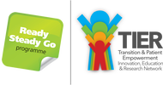
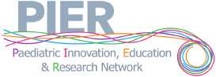

16th Annual Nephro-Urology Study Day
for Paediatricians and the Multi-Disciplinary Team

20th February 2024
09:15– 09:35 | Registration
09:35 – 09:40 | Welcome
09:40 – 10:10  10.15 – 10: 04  10:45 – 11:10 | An approach to a high plasma creatinine and discordant urea and creatinine results.  Inherited nephritis, and haematuria genetic testing  Save the veins project | Prof Rodney Gilbert  Dr Mira Kharbanda  Mrs Sarah Grylls
11:10 – 11:30 | Coffee Break
11:35 – 12:30 | Urology Round Table. | Mr Stephen Griffin,  Mr Manoharan Sengamalai,  Mr Ewan Brownlee
12:30 – 13:30 | Lunch
13:30 – 15:15 | Cases From Around the Region: | TBC
15:15 - 15:35 | Coffee Break
15:35 – 16:10  16:10 – 17:00 | Obesity and the Kidney  Diabetic Nephropathy | Prof Rodney Gilbert  Dr Shuman Haq
17:00 | Close of meeting

This meeting has been supported by pharmaceutical companies through the purchase of exhibition trade space only and is limited to meeting the costs of the scientific programme.

