Management of children presenting to primary care with Viral Lower Respiratory Tract Infections (Bronchiolitis and Viral induced wheeze)
August 2021
Clare Harris (Primary Care Lead, Hampshire CCGs) | Sanjay Patel (Paediatric ID consultant and Programme Lead, Healthier Together)
Zena Penny (Primary care lead, Southampton) | David James (Paediatric EM Consultant and Emergency Care Lead, Healthier Together)
Sally Robins (Primary care lead, SE Hampshire) | Julia Shaw (Paediatric Lead, HHFT)
Natalie Smith (Primary care lead, North Hampshire) | Jo Borbone (Paediatric Lead, QA Hospital, Portsmouth)
Kathryn Bannell (Primary care lead, SE Hampshire & Portsmouth) | Mark Alderton (Paediatric Lead, Southampton Children’s Hospital)
Olie Morris (GP and Primary Care Lead, Healthier Together) | Sian Butterworth (Paediatric Lead, St Mary’s Hospital, IoW)
Aim of this document:
- There is evidence to suggest an imminent and significant increase in Viral Lower Respiratory Tract Infections (LRTI) in pre-school children (Bronchiolitis and Viral Induced Wheeze).
- This document sets out to provide guidance for primary care staff on the assessment and management of children presenting with viral LRTIs (Bronchiolitis and Viral Induced Wheeze), including criteria for when to refer a child to secondary care.
- It promotes a consistent approach for clinicians working across the urgent care pathway.
- It aims to enhance parent education and empowerment by providing clear information about when to seek healthcare consultations. This can be sent by GP practices to parents/carers via MJOG and/or ACCURX (https://what0-18.nhs.uk/worried-your-baby-unwell-under-3-months-2/worried-about-your-baby / https://what0-18.nhs.uk/parentscarers/worried-your-child-unwell) .
Background:
- The non-pharmacological interventions implemented during the COVID-19 pandemic not only reduced transmission of SARS-CoV-2 but also significantly reduced the transmission of all other respiratory viruses.
- There were almost no cases of bronchiolitis during the winter of 2020/21.
- Data from the Southern hemisphere showed an interseason surge in babies and young children presenting with RSV in late 2020 following the easing of COVID-19 restrictions, and a significant rise in RSV is currently being seen in the North West of England.
- NHSE have recently restarted the Palivizumab (passive immunisation against RSV ) programme for the most vulnerable young children and plan to offer monthly doses for the next 7 months.
- Modelling performed by Public Health England has estimated a possible 100% increase in bronchiolitis cases compared to winter averages.
- Whether cases will continue to rise now that schools have broken up remains unclear; it is possible that a significant surge in cases may be delayed until September. It is likely that the main paediatric presentations associated with a surge in respiratory viruses will be Bronchiolitis (in children up to 2 years of age) and Viral Induced Wheeze. Although an increase in hospital admissions is predicted, the majority of presentations will be to primary care.

Approach:
- It is suggested that primary care clinicians use the approach described in the Healthier Together clinical pathways for bronchiolitis and viral induced wheeze. If in doubt about the diagnosis please use the clinical pathway for Cough & Breathlessness in children <2 years.
- It is recommended that primary care clinicians are able to accurately measure oxygen saturations using paediatric saturation probes as part of a full respiratory assessment. In general, sats of <92% should generate a discussion or referral to secondary care. All those under 6 weeks or with comorbidities should be referred.
- Viral LRTIs generally present with cough and difficulty breathing. The child may be coryzal, febrile and have difficulty feeding or drinking.
- Traditionally, Bronchiolitis has been viewed as a condition affecting those under 1 in the UK. However this year we are expecting more children 1-2 to present with a more ‘bronchiolitic’ phenotype than traditional wheeze.
- The main reason to differentiate between the conditions is to provide timely bronchodilator therapy to those wheezers who will benefit while NOT administering this to younger babies with more classical Bronchiolitis.
Here is a table to help differentiate the assessment and treatment of Bronchiolitis and Viral Induced Wheeze:
 | Bronchiolitis | Viral Induced Wheeze
Age | Most commonly <1. Can be up to 2 | 1+
History | Often starts with coryza leading to cough and breathlessness | Often starts with coryza leading to cough and breathlessness
Examination | May have tachypnoea and respiratory distress  Course bilateral scattered crackles | May have tachypnoea and respiratory distress  Bilateral wheeze or crackles heard only on expiration  May have reduced air entry
Worrying features in history | Early on in illness (often gets worse over 3-4 days)  Under 6 weeks  Co-morbidities (congenital heart disease, immunocompromised, chronic lung disease, age <6 weeks, Prematurity, Neuromuscular weakness) | Previous episodes requiring HDU/ITU care  Previous episodes requiring IV therapy
Treatment in primary care | Supportive  Establish feed plan little and often | Salbutamol up to 10 puffs up to 4 hourly  Prednisolone 1mg/kg OD for 3 days or Dexamethasone 0.3mg/kg x 1 if history of atopy
Safety netting advice sheet | Bronchiolitis :: Healthier Together (what0-18.nhs.uk) | Viral induced wheeze :: Healthier Together (what0-18.nhs.uk)
Referral details for your local hospital | Hospital advice/referral contact details :: Healthier Together (what0-18.nhs.uk) | Hospital advice/referral contact details :: Healthier Together (what0-18.nhs.uk)
Acute community paediatric nursing services are available in North Hampshire and Portsmouth, SE Hants and Fareham & Gosport – referral may be considered for amber patients being managed at home (click here for contact details).
Assessment and Treatment of Severe disease:
Bronchiolitis
This is taken from the Healthier Together Bronchiolitis pathway – the full version is here
ASSESSMENT FEATURES: ANY of the following
Clinical Findings | Red – high risk
Behaviour | Unable to rouse  No response to social cues  Wakes only with prolonged stimulation  Week or continuous cry  Appears ill to a healthcare professional
Skin | CRT > 3 seconds  Cyanosis  Grey/Mottled
Respiratory Rate | >70 breaths /minute  Apnoeas
Oxygen sats in air
Chest recession | Severe
Nasal Flaring | Present
Grunting | Present
Feeding/Hydration | <50% fluid over 2-3 feeds/12 hours  Appears dehydrated  Significantly reduced urine output
Other

ACTIONS
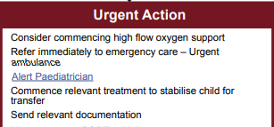

Assessment and Treatment of Severe disease:
Viral Induced Wheeze
This is taken from the Healthier Together Wheeze pathway – the full version is here
ASSESSMENT FEATURES: ANY of the following
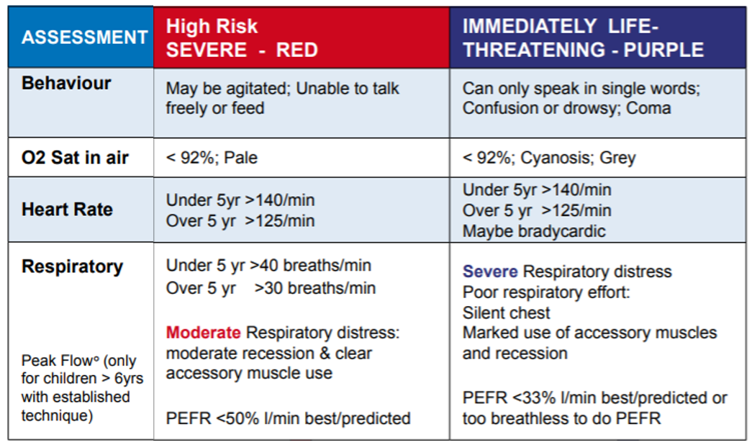
ACTIONS:
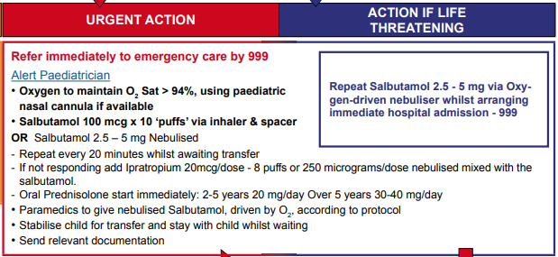
- Nebulised salbutamol should be reserved for severe / life threatening wheeze and given pending transfer to hospital. Nebulisation is not an aerosol generating procedure (AGP) and therefore does not require you to wear full PPE or an FP3 mask.

Assessment and Treatment of Moderate disease:
Bronchiolitis
This is taken from the Healthier Together Bronchiolitis pathway – the full version is here
ASSESSMENT FEATURES: ANY of the following
Clinical Findings | Amber – Intermediate risk
Behaviour | Irritable  Decreased activity  Reduced response to social cues  No smile
Skin | CRT 2-3 seconds  Cool peripheries  Pale
Respiratory Rate | 50-70 breaths / minute
Oxygen sats in air | <92%
Chest recession | Moderate
Nasal Flaring | May be present
Grunting | Absent
Feeding/Hydration | 50-75% fluid intake over 3-4 feeds  Reduced urine output
Other | Pre-existing lung condition  Immunocompromised  Congenital heart disease  Additional parent/carer support needed | Age < 6 weeks  Prematurity  Re-attendance  Neuromuscular weakness

ACTIONS:
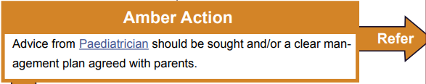
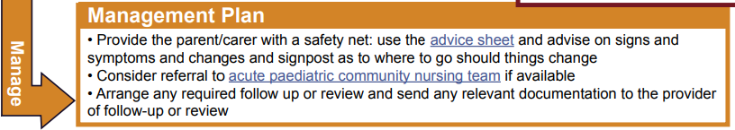

Assessment and Treatment of Moderate disease:
Viral Induced Wheeze
This is taken from the Healthier Together Bronchiolitis pathway – the full version is here
ASSESSMENT FEATURES: ANY of the following
Clinical Findings | Amber – Intermediate risk
Behaviour | Alert  Some increased work of breathing
Oxygen sats in air | 92-94%  Pink
Heart Rate | Under 5: <140  Over 5: <125
Respiratory Rate | Under 5: <40 breaths / minute  Over 5: <30 breaths / minutes
Respiratory Distress | Mild (including mild recession and some accessory muscle use)
Peak Flow (6y+) | 50-75% l/min best / predicted

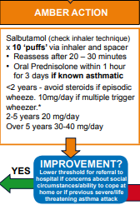
ACTIONS:
NO
RED action
GREEN action

Assessment and Treatment of Mild disease:
Bronchiolitis
This is taken from the Healthier Together Bronchiolitis pathway – the full version is here
ASSESSMENT FEATURES:
Clinical Findings | Green – Low risk
Behaviour | Alert  Normal
Skin | CRT<2 seconds  Normal colour skin, lips and tongue  Moist mucous membranes
Respiratory Rate | <50 breaths / minute
Oxygen sats in air | 92% or above
Chest recession | Mild
Nasal Flaring | Absent
Grunting | Absent
Feeding/Hydration | Normal – 75% or more fluid intake  Occasional cough induced vomiting
Other

ACTIONS:

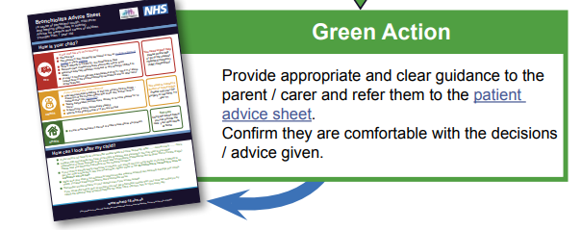

Assessment and Treatment of Mild disease:
Viral Induced Wheeze
This is taken from the Healthier Together Bronchiolitis pathway – the full version is here
ASSESSMENT FEATURES:
Clinical Findings | Green – Low risk
Behaviour | Alert  No increased work of breathing
Oxygen sats in air | >95%  Pink
Heart Rate | Under 5: <140  Over 5: <125
Respiratory Rate | Under 5: <40 breaths / minute  Over 5: <30 breaths / minutes
Respiratory Distress | None  Normal respiratory effort
Peak Flow (6y+) | >75% l/min best / predicted

